
User Solutions, Inc.
(800)321-USER(8737)
11009 Tillson Drive
South Lyon, MI 48178
ph: (248) 486-1934 fax: (248)486-6376
www.usersolutions.com us@usersolutions.com

Operations Manager for Excel (C) 1997-2003, User Solutions, Inc.

General Purpose Operations and Manufacturing Management Templates. All materials are COPYRIGHTED. No part of the software or documentation may be reproduced in any form, without express permission from User Solutions, Inc.

Contact US: EMAIL: us@usersolutions.com, PH: (248) 486-1934 FAX: (248) 486-6376

Please visit our website, www.usersolutions.com for information on other flexible and easy-to-use solutions.

Material Requirements Planning Section

4.1 MRP inventory plan (MRP1) 36

4.2 Period-order-quantity (POQ) 39

MRP1 develops detailed inventory plans for individual items for up to 20 weeks into the future. In MRP systems, demand for component parts tends to be "lumpy," that is discontinuous and nonuniform, with frequent periods of zero demand. The POQ model is an alternative lot-sizing model for coping with lumpy demand.
4.1 MRP inventory plan (MRP1)

MRP1 computes weekly net requirements for an inventory item for up to 20 weeks in the future. The model then schedules planned order releases and receipts to satisfy those requirements. Leadtimes can range from 0 to 6 weeks. MRP1 can handle a variety of practical complications in inventory planning, such as units previously allocated to specific future production runs, previously scheduled order receipts, lot sizing, safety stocks, and yields which are less than 100% of production quantities.

Figure 4-1 shows a complete inventory plan for drive shaft X552-6, part of a hoist assembly manufactured by Houston Oil Tools. The leadtime to produce X552-6 is presently 1 week. Management is considering rebuilding one of the three machine tools used to produce X552-6. For the next several months, leadtime will increase to at least 2 weeks while the machine is out of service. Can we still meet the gross requirements in Figure 4-1 with a leadtime of 2 weeks?

To answer this question, let's review the logic behind MRP1. The beginning inventory is 50 units, with 20 units allocated to future production. Thus the initial inventory available is 50 - 20 = 30 units. The lot size for this item is 100 units and 50 units are maintained in safety stock. Past experience shows that the yield is 98%; that is, for every 100 units produced, only 98 are of acceptable quality. Gross requirements for the shaft are shown in row 11. The company uses a planning horizon of 8 weeks, so the cells for weeks 9-20 contain 0 in row 11. Row 12 is reserved for any previously scheduled receipts from earlier inventory plans.

Projected inventory on hand at the beginning of each week is computed as follows: (inventory on hand last week) - (gross requirements last week) + (planned order receipts last week) + (scheduled receipts this week).

Net requirements in row 16 are: (gross requirements this week) + (safety stock) - (inventory on hand at the beginning of this week). Net requirements cannot be negative in MRP1. If this formula results in a negative value, the model resets net requirements to zero.

Planned order receipts in row 17 are computed to satisfy all net requirements. If the lot size in cell F6 is entered as 1 (indicating lot-for-lot ordering), planned order receipts are equal to net requirements. Otherwise, net requirements take into account the lot size. If cell F7 is set to 1, net requirements are converted to planned order receipts by rounding up to the nearest even multiple of the lot size. For example, the net requirement of 215 units in week 3 rounds up to a planned order receipt of 300 units.
Figure 4-1
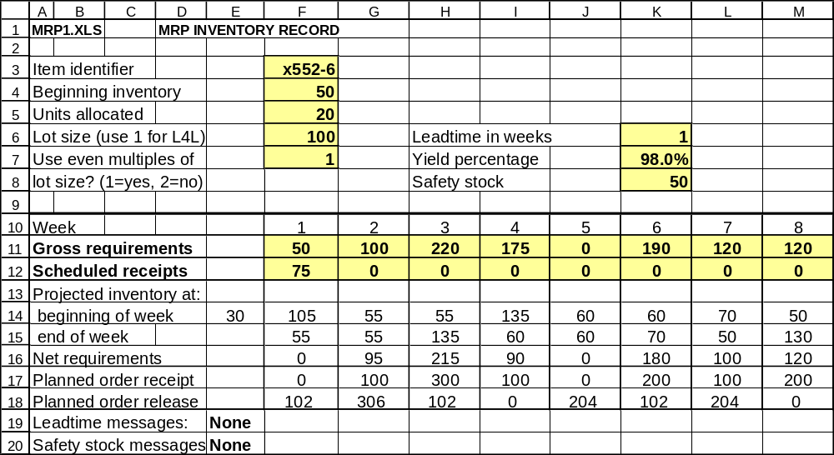

Some companies treat the lot size as a minimum and do not round up to the nearest even multiple. Net requirements less than the minimum lot size are rounded to that lot size; net requirements that exceed the minimum lot size are left alone. For example, if you enter 2 in cell F7, the net requirement of 215 is not rounded and the quantity is simply used as is.

Planned order releases are offset by the length of the leadtime and adjusted by the yield percentage. The planned order receipt of 300 units in week 3 must be released in week 2 since the leadtime is 1 week. Furthermore, we expect only 98% of total units to be acceptable, so the quantity must be increased by the factor (1/yield percentage). Thus we have to produce 306 units to get 300 of acceptable quality.

In the area below the schedule, error messages are displayed if leadtime is inadequate to satisfy a net requirement. To see how this works, enter a leadtime of 2 in cell K6. The planned order releases shift to the left by one week and you get the following message: "Not enough leadtime to meet net rq. in week 2." Houston Oil Tools must adjust the master schedule that generated the gross requirements or find some other way to avoid the leadtime problem. The model automatically checks the first 6 weeks of the schedule for leadtime problems. You will also get an error message if leadtime is less than zero or greater than 6 weeks.

Now let's try another experiment. Change the leadtime back to 1, then change the gross requirement in week 1 to 100. This produces 2 error messages: "Not enough leadtime to meet net rq. in week 1" and "Net rq. due only to safety stock in week 1." The net requirement of 45 units has nothing to do with meeting the production schedule. Instead it merely keeps safety stock at required levels. In this example, Houston Oil Tools reset the safety stock in cell K8 to 0 to avoid generating artificial requirements.

To solve a new problem, enter the input data requested in F3..F7 and K6..K8. Next, enter gross requirements and scheduled receipts in rows 11 and 12.

MRP1 makes it easy to do a great deal of what-if analysis. A common problem in lot-sizing is that it frequently leads to carrying excess stock during periods of low demand. You can attempt to minimize excess stock by trying different lot sizes. If leadtimes are uncertain, you can add "safety leadtime" by trying larger leadtime values. If yields are uncertain, you can decrease the yield percentage. Another option is the POQ model in the next section.
4.2 Period-order-quantity (POQ)

Production economics may dictate the use of lot-sizing in MRP systems but the EOQ rarely works very well. The problem is that the EOQ is based on the assumption that demand is continuous and uniform. In MRP systems, demand for component parts tends to be "lumpy," that is, discontinuous and nonuniform, with frequent periods of zero demand. When the EOQ is applied to lumpy demand, lot sizes usually don't cover whole periods of demand. The result is that unnecessary inventory is often carried during the periods following the receipt of a lot. This unnecessary inventory is called "remnants" because it is left over from previous lots. The period-order-quantity (POQ) model was designed to avoid remnants and give lower costs with lumpy demand.

Houston Oil Tools has noticed a remnant problem with pulley assembly number A333-7, as shown in the lot-sizing worksheet in Figure 4-2. Demand over the 8-week planning horizon for this item is 825 units. Demand varies drastically, with no demand at all during weeks 2 and 5. The EOQ is 194 units, with receipts in weeks 1, 3, 6, and 8. Relatively large stocks are carried every week during the planning horizon.

The logic behind the POQ is straightforward. As in the EOQ, the aim is to balance ordering and holding costs, but we order only in whole periods of demand. To determine the number of periods to order, the first step is to compute the EOQ quantity. Next, we determine the average number of periods of demand covered by the EOQ. In Figure 4-2, average weekly demand is 103.1 units. The EOQ is 194, so it covers an average of 194/103.1 = 1.9 weeks of demand. This rounds to an "economic order period" of 2 weeks, meaning that we always order 2 whole weeks of demand at a time. Demand for the first 2 weeks is 100 units. 25 are on hand at the beginning, so we order 75 units in week 1. There is no remnant to carry over to week 2. Contrast this to the EOQ policy. The 194 units received in week 1 result in a remnant of 119 units carried to week 2. Using the POQ, we don't order again until demand occurs in week 3. Demand for the next 2 weeks (weeks 3 and 4) is 225 units, so we order exactly that amount, and so on.

Costs for each model are computed as follows. Ordering cost is the cost per order in cell D8 times the number of orders placed. Holding cost is the cost per unit per week times the sum of the ending inventory balances. Total costs are the sum of ordering and holding costs. In this problem, the POQ makes a significant reduction in total cost because there are only two periods in which any inventory at all is carried. Contrast this to the EOQ, which carries inventory every period.

To analyze a new problem, complete the input cells in the top section of the worksheet. You must specify the number of weeks of demand in the planning horizon in cell D10. Any demand beyond that point is ignored. In row 16, enter demand for up to 20 weeks. The demand can be a file of net requirements extracted from the MRP1 worksheet.
Figure 4-2

